**E COMMERCE MOBILE APPLICATION**



**CONTENTS**

**1 INTRODUCTION…………………………………………… 3**

**2 TECHNOLOGIES INVOLVED............................................. 4**

**2.1 Mobile App Development Tools..........…………………… 4**

**2.1.1 Java………………………………………………………. 5**

**2.1.2 Android Studio………………………………………….. 5**

**2.1.3 Fire Base ………………………………………………… 5**

**2.1.4 REST API……………………………………………… .. 5**

**3 PROJECT REQUIREMENTS……………………………… 5**

**4 PRACTICAL IMPLEMENTATIONS…………………….... 6**

**4.1 Application overview............................................................ 7**

**5 MOBILE APPLICATION IMPLEMENTATIONS .................... 8**

**6 FIREBASE SERVICES………………………………… 18**

**7 CONCLUSION/FUTURE ENHANCEMENT…………….. 20**

**8 REFERENCES………………………………………………. 20**

**Abstract: -**

This project is all about selling the Non- perishable products online in bulk quantity. It can be anything like those human needs like some of them I am listing, Clothes & Machines.

So, to accomplish this task I am developing an android application that will be capable of showing the products and take the order from the customer end and update them about their order.

For designing the app I am using the android studio which I give to my app design and as well as the functionality. The app will consist of a number of widgets with the help of the number of layout methods to layout the components of the android app. For the back-end I am using google-firebase that will store the information of our products and the user on the internet.

With this project-idea I have learnt so many things in the field of computers and how e-commerce websites work online. And I believe that it is important to do so because there are so many companies out there in India who sell the products at the price of gold and they are taking so much of money out of our nation. So, it will be good to implement this project-idea.

**Introduction**: -

E-commerce is fast gaining ground as an accepted and used business paradigm. More and more business houses are implementing web sites providing functionality for performing commercial transactions over the web. It is reasonable to say that the process of shopping on the web is becoming commonplace. The objective of this project is to develop a general-purpose e-commerce store where products like clothes can be bought from the comfort of home through the Internet. However, for implementation purposes, this paper will deal with online shopping for clothes. An online store is a virtual store on the Internet where customers can browse the catalogue and select products of interest. The selected items may be collected in a shopping cart. At checkout time, the items in the shopping cart will be presented as an order. At that time, more information will be needed to complete the transaction. Usually, the customer will be asked to fill or select a billing address, a shipping address, a shipping option, and payment information such as credit card number. An e-mail notification is sent to the customer as soon as the order is placed.

**1.** **INTRODUCTION TO MOBILE APP DESIGN**

The application that I tend to do is an E-commerce mobile application. The app includes two roles, which are admin and user. Users can view and buy the products that are available in the application while admins are allowed to manage those products. The main function of this application is that users can search, view and select the products that they want to buy in bulk quantities. An admin can manage products by adding or deleting an item, as well as upload pictures and descriptions for products.

The Documentation will be divided into different parts, described as follows:

• Part 1 (Introduction) provides general information about the E-commerce  Application

• Part 2 (Theoretical Background) describes the definition of the method that is used in the Application to create the solution for the topic

 • Part 3 (Implementation) explains the process of development and Implementation

 • Part 4 (Conclusion) summarises the outcome of the topic

**2 TECHNOLOGIES INVOLVED:**

It will provide both basic and detailed knowledge of methods that are used to develop the mobile application. Following that, the requirements for the application and a brief introduction to mobile development are also described.

**2.1** **MOBILE APPLICATION DEVELOPMENT:**

Mobile applications can be divided into three types, which are native application, hybrid application and cross-platform application.  We can approach mobile application development as a hybrid application. Another approach is cross-platform application. Cross-platform application is closest to a native application. The code base is written in JavaScript and connects to native components using bridges. It allows sharing code between different platforms, therefore, with one code base we can develop applications for both Android and iOS. Some cross-platform tools which allow creating cross-platform applications is React Native. The application in this project is considered as Native  application which is limited to Android Mobiles..

**2.1.1 JAVA:**

Java is a widely used object-oriented programming language and software platform that runs on billions of devices, including notebook computers, mobile devices, gaming consoles, medical devices and many others. The rules and syntax of Java are based on the C and C++ languages.

**2.1.2 ANDROID STUDIO:**

Android Studio is the official integrated development environment (IDE) for Android application development. It is based on IntelliJ IDEA, a Java integrated development environment for software, and incorporates its code editing and developer tools.

**2.1.3 FIRE BASE:**

Firebase is a backend platform for building Web, Android and IOS applications. It offers a real time database, different APIs, multiple authentication types and hosting platform.

**2.1.4 REST API:**

REST API is an interface that two computer systems use to exchange information securely over the internet. Most business applications have to communicate with other internal and third-party applications to perform various tasks.

**3. PROJECT REQUIREMENTS:**

As a result, the application should be working with the provided features. The application will have two roles, which are users and admins. For users, they can use all the features as follows:

• Sign in and sign out

• Register

• Search and select products

• Checkout process: Fill in shipping form, choose payment method, confirm order, track order

**Functionality performed by the customer: -**

Register for customers.

login for customers.

Change or forgot password.

Edit profile for customer.

View his shopping and payment history.

**Functionality for admin: -**

Manage customers.

View profile of the customer.

Manage products.

Manage category.

Manage shipping.

There is one tab for admin to manage the products. Admins are allowed to do these actions as follows:

 • Add and update products

 • Delete products

 • Upload products’ image

 • Update orders’ status

 • Add categories

**4** **. PRACTICAL IMPLEMENTATIONS:**

This section is divided into three parts, which are application overview, server implementation, and mobile application implementation. The first part is about which features are included in the application. The second part will cover the details about what is the plan for the server and how it was implemented. The last part will be about the implementation of the mobile application. To provide a clearer picture of the implementation process, I will use the following typography in this section:

• API paths will be in bold

• Code snippets are colour-coded

• Code quotes are in italic; the syntax makes it easier to follow the implementation part.

**4.1 APPLICATION OVERVIEW:**

The mobile application provides a platform that contains two roles which are user and admin. For users, they can search, select and order products that they demand. For admins, the application is used to manage all the available products. Moreover, they can also add new products to the platform. 11 The following list will describe the features and functions that are available in the mobile application to make it simpler to understand how it works:

• Product list includes all the available products so that users can search for products and view their details. They can search products by their name using the search bar or by categories. Users can also add the wanted items to their shopping cart.

• The shopping cart displays all the items that are selected by a user. Users can do the checkout process in the cart. The checkout process will include a form for shipping information, payment method, and confirmation before placing an order.

• User management allows users to sign in and sign out the application. Moreover, users can also see their profile.

• Product management is only available for accounts that have admin rights. The admin rights will include product management, category management, and order management. Admins can add a new product with all the required information. They can also manage orders by updating their status. In order to fulfil the requirements, a database and server are needed to implement the mobile application. The database is used to store all the data that is used in the mobile application. The server is used to serving the requests to retrieve and manage data from the mobile side.

**5. MOBILE APPLICATION IMPLEMENTATIONS:**

**Output / Result / Screenshot: -**

**5.1 Splash Screen:** splash screen is a brief introductory screen that appears when an application is launched. It typically displays the app's logo, branding, or a visually appealing image while the app initialises and loads its resources.



**5.2 Registration Page:** Allowing users to Register using their Details Like Email, Password & other details which provides a convenient and secure authentication method.

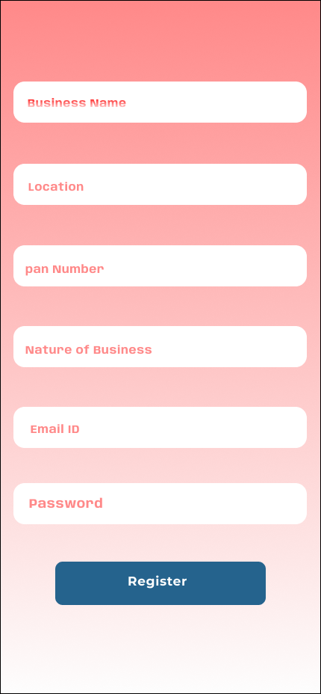

**5.3 Login Account:** Enabling users to enter email Id & Password is a common method for verifying their identity during processes like login.

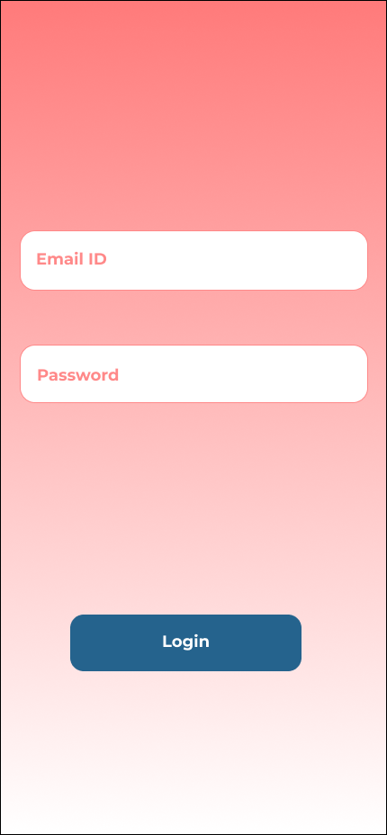

**5.4 Product Category:** This section gives the information on the product category list. After a user pushes the icon, which works as a button he/she will be taken to this section, and the user can view the list of the categories available in the system. This product category item also works as a button, as mentioned before**.**

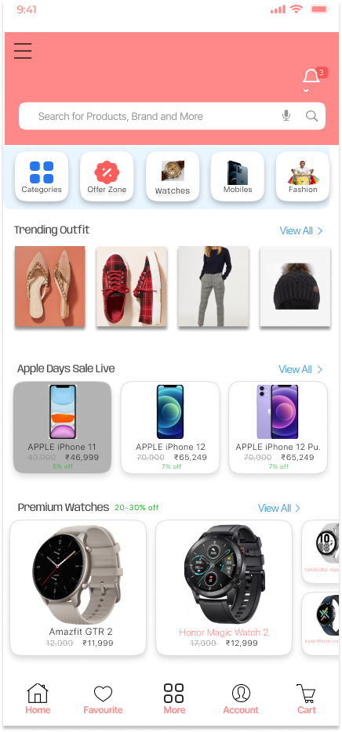

**5.5 Product Details:** This section displays essential product information, such as name, description, category, images, brand, price.

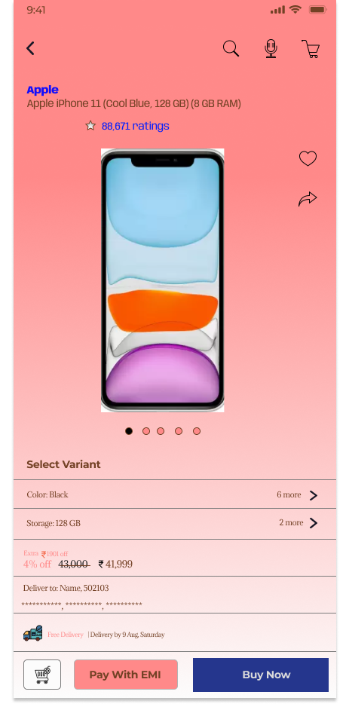

**5.5 Order Details:** Providing clear and transparent order details is crucial for enhancing the user experience and building trust in your e-commerce platform. This section displays delivery address, delivery charges, and discounts to users.

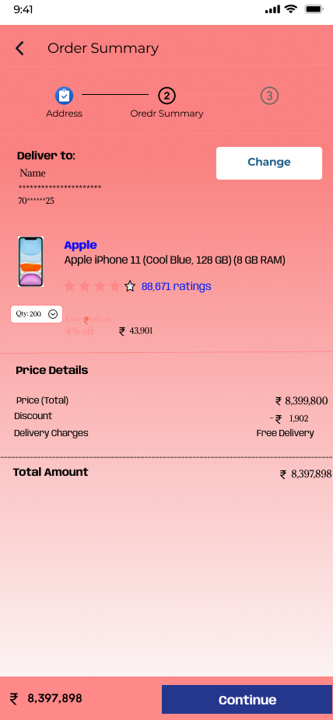

**5.6 Payments:** The payment page comes after the user clicks the continue button, which will take the user to the payment page. The user needs to provide their payment information according to the system to finalise the process.

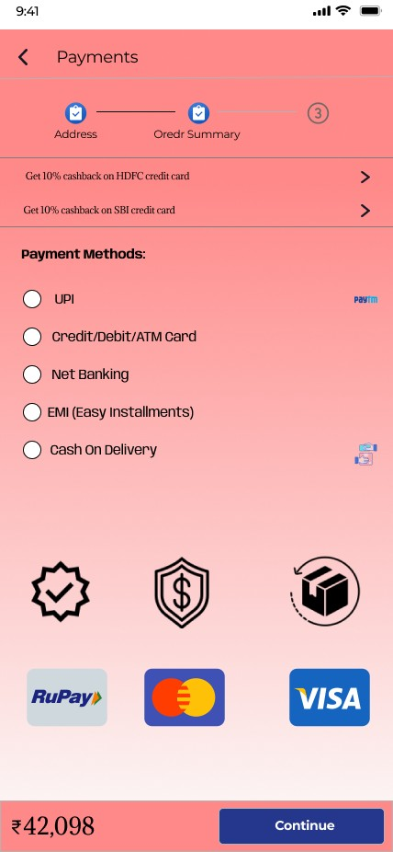

**5.7 Order Confirmation:** After a user completes their purchase, providing a clear and reassuring confirmation message is essential to enhance their experience and confidence on e-commerce platforms.

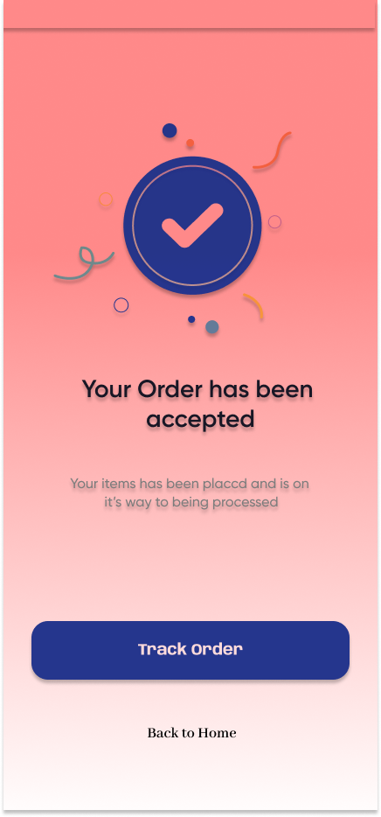

**5.8 Logout:** This Section displays Implementing a secure and user-friendly logout process is crucial to maintaining user privacy and security on application.

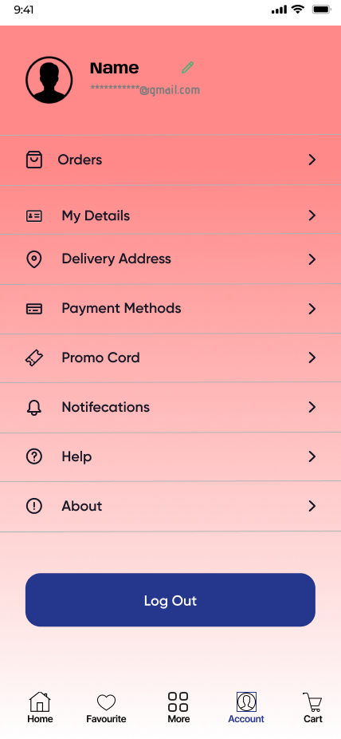

**5.9 My Cart:** The shopping cart is a critical component of any e-commerce platform, allowing users to review and manage their selected items before making a purchase. Designing an efficient and user-friendly shopping cart enhances the overall shopping experience and encourages users to complete their transactions. Here's how you can create an effective shopping cart.

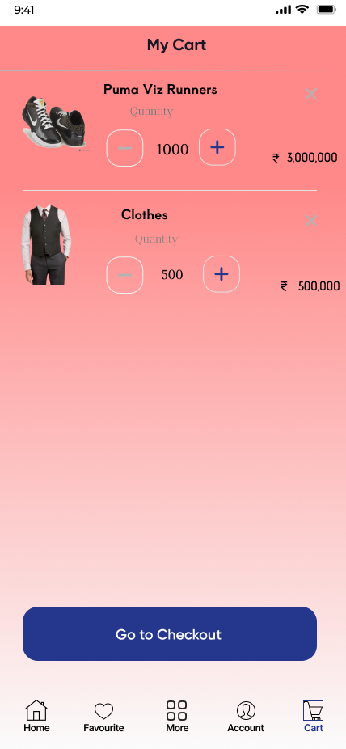

**5.10 Favourite**: Favourites feature on  e-commerce platform allows users to save and keep track of products they are interested in or plan to purchase in the future. This feature not only enhances user engagement but also provides a personalised experience.

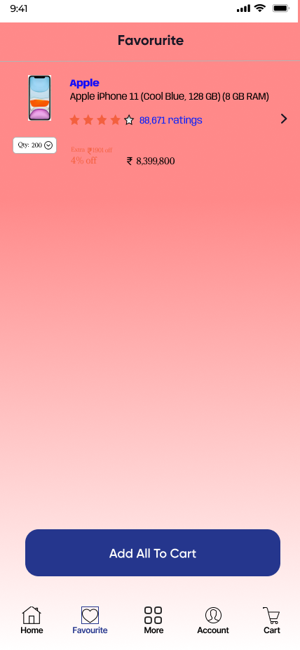

**6.** Fir**ebase Services: -**

**Realtime Database**

The Firebase Realtime Database is a cloud-hosted NoSQL database that lets you store and sync between your users in Real Time.

The Realtime Database is really just one big JSON object that the developers can manage in Real Time.

With just a single API, the Firebase database provides your app with both the current value of the data and any updates to that data.

Real Time syncing makes it easy for your users to access their data from any device, be it web or mobile. Realtime Database also helps your users collaborate with one another.

Another amazing benefit of Realtime Database is that it ships with mobile and web SDKs, allowing you to build your apps without the need for servers.

When your users go offline, the Realtime Database SDKs use local cache on the device to serve and store changes. When the device comes online, the local data is automatically synchronised.

The Realtime Database can also integrate with Firebase Authentication to provide a simple and intuitive authentication process

**Implementation or architecture diagram:**

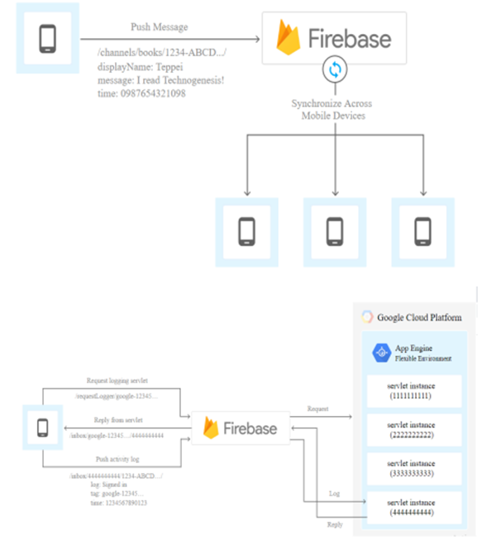

**Authentication:** -

Firebase Authentication provides backend services, easy-to-use SDKs, and readymade UI libraries to authenticate users to your app.

Normally, it would take you months to set up your own authentication system. And even after that, you would need to keep a dedicated team to maintain that system. But if you use Firebase, you can set up the entire system in under 10 lines of code that will handle everything for you, including complex operations like account merging.

You can authenticate your app’s users through the following methods:

Email & Password

Phone numbers

Google

Using Firebase Authentication makes building secure authentication systems easier, while also improving the sign-in and onboarding experience for end users

**7. Conclusion/Future Enhancement: -**

The whole conclusion of this project is to sell the products at the lowest (Wholesale) price so that every-one can buy it without any tension.

With the help of this project we will try to sell the product at the lowest price possible for us.

To accomplish this task, we need a number of technologies like the xml-to layout the app, SQLite to store the data in the phone locally.

from the admin panel the admin will be able to edit, add and many more operations.

**8. References: -**

Bit help from the internet to design the layout of the app using different layout methods will run our android app.